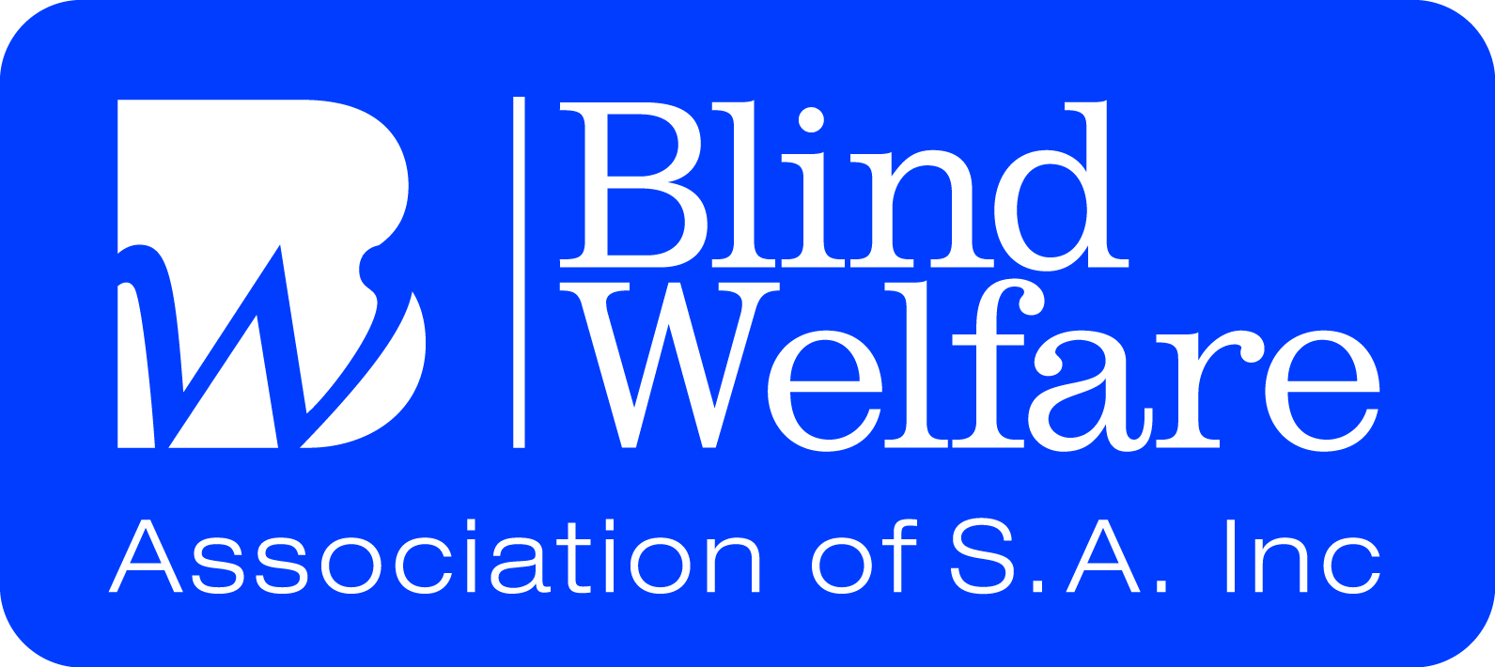

Social Activities for TERM 3 2016

All Members are welcome to attend any and all of the activities in the program.

Please contact the BWA office to attend as some activities require attendance numbers in advance for transport and catering
PHONE: 8 3 6 7 6 0 8 8

All Social Centre Activities incur a $3.00 fee
This fee contributes to keeping the Centre running.
(Cleaning, Utility Costs, Catering Supplies, Transport & More)

Lunches available at Social Centre activities
From $3.00

July WEEK 1

Monday 25^{tn} Social Club 1.00 – 3.00
Dean Bird 1.30 – 2.30

Tuesday 26th Cooking Demon 10.30 – 1.00
Ginger Chicken & Fried Rice

Wednesday 27thChat ‘n’ Craft 10.00 – 12.30

Thursday 28th Social Group 10.00 - 3.00
Welcome Back Lunch
Surprise Menu $5.00

Friday 29th Chat ‘n’ Craft 10.00 – 12.30
Shopping 10.30 – 12.00
Bingo 1.00 - 2.00

August WEEK 2

Monday 1st Social Club 1.00 – 3.00
BWA Quiz Mania 1.30 – 2.30

Tuesday 2nd Kaleidoscope Movie
Arts Group 10.00 – 12.30

Wednesday 3rdChat ‘n’ Craft 10.00 – 12.30
Tech Corner 10.00 – 12.30

Thursday 4th Social Group 10.00 – 3.00
ABC Tour 11.30 – 12.30
Lunch at ABC Cafe

Friday 5th Chat ‘n’ Craft 10.00 –12.30
Walking Group 10.30–12.00

WEEK 3

Monday 8th Social Club 1.00 – 3.00
KingFisher Duo 1.30 – 2.30

Tuesday 9th A.D. Movies 10.00 – 12.30

Wednesday 10thChat ‘n’ Craft 10.00 – 12.30

Thursday 11th Social Group 10.00 – 2.00pm
Scattergories
Pizza Lunch $5.00

Friday 12th Chat ‘n’ Craft 10.00 – 12.30
Bingo 1.00 - 2.00

WEEK 4

Monday 15th Social Club 1.00 – 3.00
Jody from Access to Arts
1.30 – 2.30

Tuesday 16th A.D. Movies 10.00 – 12.30
Arts Group 10.30 – 12.00

Wednesday 17thChat ‘n’ Craft 10.00 – 12.30

Thursday 18th Social Group 10.00 – 2.00
McQueen’s 12.00

Friday 19th Chat ‘n’ Craft 10.00 – 12.30
Walking Group 10.30 – 12.00

WEEK 5

Monday 22nd Social Club 1.00 – 3.00
The Voice of BWA
Talent Quest

Tuesday 23rd A.D. Movies 10.00 – 12.30

Wednesday 24thChat ‘n’ Craft 10.00 – 12.30

Thursday 25th Social Group 10.00 – 2.00
Middle Eastern Lunch $6.00

Friday 26th Chat ‘n’ Craft 10.00 – 12.30
Bingo 1.00 - 2.00

WEEK 6

Monday 29th Social Club 1.00 – 3.00
Helen & John 1.30 – 2.30

Tuesday 30th Cooking Demo 10.30 – 1.00
Wednesday 31stChat ‘n’ Craft 10.00 – 12.30

September

Thursday 1st Social Group 10.00 – 2.00
RSB Smithfield
Low Tech Tour
Lunch T.B.A

Friday 2nd Chat ‘n’ craft 10.00 – 12.30 Walking Group 10.30 –12.00

WEEK 7

Monday 5th Social Club 1.00 – 3.00
BWA Quiz Mania

Tuesday 6th A.D. Movies 10.00 – 12.30

Wednesday 7thChat ‘n’ Craft 10.00 – 12.30
Tech Corner 10.00 – 12.30

Thursday 8th Social Group 10.00 – 2.00
European Lunch $6.00

Friday 9th Chat ‘n’ Craft 10.00 – 12.30
Bingo 1.00 - 2.00

WEEK 8

Monday 12th Social Club 1.00 – 3.00
Matinee Entertainers -
1.30–2.30

Tuesday 13th A.D. Movies 10.00 – 12.30

Wednesday 14thChat ‘n’ Craft 10.00 – 12.30

Thursday 15th Social Group 10.00 – 2.00
Southern Hotel 12.00
Lunches start at $7.90

Friday 16th Chat ‘n’ craft 10.00 – 12.00
Walking Group 10.30 – 12.00

WEEK 9

Monday 19th Social Club 1.00 – 3.00 Encounter Ensemble -
1.30–2.30

Tuesday 20th A.D. Movies 10.00 – 12.30
Arts Group 10.30 – 12.00

Wednesday 21stChat ‘n’ Craft 10.00 – 12.30

Thursday 22th Social Group 10.00 – 2.00
Spring B.B.Q $6.00

Friday 23rd Chat ‘n’ craft 10.00 – 12.30
Bingo 1.00 - 2.00

WEEK 10

Monday 26th Social Club 1.00 – 3.00
Something Funny Happened…..
Everyone has a funny story so please tell us!

Tuesday 27th A.D. Movies 10.00 – 12.30

Wednesday 28thChat ‘n’ Craft 10.00 – 12.30

Thursday 29th Social Group 10.00 – 2.00
Whispering Wall
Williamstown Bakery Lunch

Friday 30th Chat ‘n’ Craft 10.00 – 12.30
Walking Group 10.30 – 12.00

Members’ input and ideas for the Social Centre activities are very welcome
Please speak with Trudy
PHONE: 8 3 6 7 6 0 8 8

SCHOOL HOLIDAYS BEGIN
ON Monday 3rd October

CENTRE RE-OPENS
ON Monday 17th October

Holiday Program
To Be Advised

