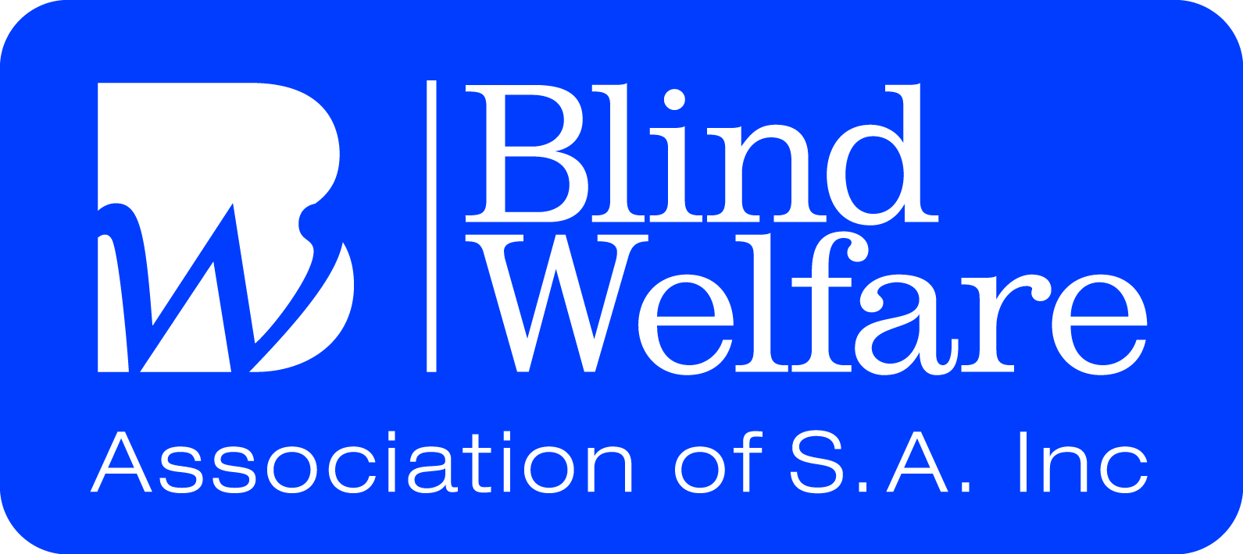

Social Activities for TERM 2 2016
May WEEK 1
Monday 2nd Social Club 1.00 – 3.00
BWA Quiz Mania

Tuesday 3rd A.D. Movies 10.00 – 12.30
Arts Group 10.30 – 12.30

Wednesday 4th Chat ‘n’ Craft 10.00 – 12.30

Thursday 5th Social Group 10.00 - 3.00
Money Smart Presentation
11.00 -12.00
B.B.Q Lunch - $5.00

Friday 6th Chat ‘n’ Craft 10.00 – 12.30
Bingo 1.00 - 2.00
WEEK 2
Monday 9th Social Club 1.00 – 3.00
Kingfisher Duo 1.30 – 2.30

Tuesday 10th A.D. Movies10.00 – 12.30
Last Cab to Darwin

Wednesday 11th Chat ‘n’ Craft 10.00 – 12.30

Thursday 12th Social Group 10.00 – 3.00
Whispering Wall & Bakery

Friday 13th Chat ‘n’ Craft 10.00 –12.30
Walking Group 10.30–12.00

WEEK 3
Monday 16th Social Club 1.00 – 3.00
Red Cross
Emergency Redi Plan1.30 -2.30

Tuesday 17th A.D. Movies 10.00 – 12.30

Wednesday 18thChat ‘n’ Craft 10.00 – 12.30

Thursday 19th Social Group 10.00 – 2.00pm
Sail Master 12 noon
Lunch Menu Just for Us -$12.00
Roast of the Day
Fish and Chips –
Battered, Crumbed or Grilled
Beef or Chicken Schnitzel & chips
Including the Soup, Salad and Veg bar.
Friday 20th Chat ‘n’ Craft 10.00 – 12.30
Shopping 10.30 – 12.30
Bingo 1.00 - 2.00

WEEK 4
Monday 23rd Social Club 1.00 – 3.00
Matt Raynor 1.30 – 2.30

Tuesday 24th A.D. Movies 10.00 – 12.30

Wednesday 25thChat ‘n’ Craft 10.00 – 12.30

Thursday 26th Social Group 10.00 – 2.00
Australia’s Biggest Morning Tea
$5.00 – (No Amenities)
All Proceeds go to
The Cancer Council

Friday 27th Chat ‘n’ Craft 10.00 – 12.30
Walking Group 10.30 – 12.00
Tech Corner – Tech Fest

WEEK 5
Monday 30th Social Club 1.00 – 3.00
RSB Presentation 1.30 – 2.30
Kitchen & Cooking Safety

Tuesday 31st A.D. Movies 10.00 – 12.30

JUNE

Wednesday 1st Chat ‘n’ Craft 10.00 – 12.30
Tech Corner 10.00 – 12.30
Round Table Conference Report

Thursday 2nd Social Group 10.00 – 2.00
Aussie Day - Football, Meat Pies, Kangaroos & Holden Cars
Pie Floater Lunch - $6.00

Friday 3rd Chat ‘n’ Craft 10.00 – 12.30
Bingo 1.00 - 2.00

WEEK 6
Monday 6th Social Club 1.00 – 3.00
Helen & John 1.30 – 2.30

Tuesday 7th A.D. Movies 10.00 – 12.30
Arts Group 10.30 – 12.30

Wednesday 8th Chat ‘n’ Craft 10.00 – 12.30

Thursday 9th Social Group 10.00 – 2.00
Lunch with Southern Members
Emu Hotel 12.00 noon

Friday 10th Chat ‘n’ craft 10.00 – 12.30 Walking Group 10.30 –12.00

WEEK 7
Monday 13th PUBLIC HOLIDAY
Queen’s Birthday

Tuesday 14th A.D. Movies 10.00 – 12.30

Wednesday 15th Chat ‘n’ Craft 10.00 – 12.30

Thursday 16th Social Group 10.00 – 2.00
Taste of Indian Lunch - $6.00

Friday 17th Chat ‘n’ Craft 10.00 – 12.30
Shopping 10.30 – 12.30
Bingo 1.00 - 2.00

WEEK 8
Monday 20th Social Club 1.00 – 3.00
Port Adelaide Enfield Community Services
Kylie 1.30 – 2.30

Tuesday 21st A.D. Movies 10.00 – 12.30

Wednesday 22nd Chat ‘n’ Craft 10.00 – 12.30

Thursday 23rd Social Group 10.00 – 2.00
Art Gallery Tour
(Details to Follow)
Friday 24th Chat ‘n’ craft 10.00 – 12.00
Walking Group 10.30 – 12.00

WEEK 9
Monday 27th Social Club 1.00 – 3.00
Matinee Entertainers
1.30 – 2.30

Tuesday 28th A.D. Movies 10.00 – 12.30

Wednesday 29thChat ‘n’ Craft 10.00 – 12.30

Thursday 30th Social Group 10.00 – 2.00

Family & Friends Open Day
Invite your Family & Friends to join us at the Social Centre

JULY

Friday 1st Chat ‘n’ craft 10.00 – 12.30
Bingo 1.00 - 2.00

WEEK 10
Monday 4th Social Club 1.00 – 3.00
BWA Quiz Mania

Tuesday 5th A.D. Movies 10.00 – 12.30
Arts Group 10.30 – 12.30

Wednesday 6th Chat ‘n’ Craft 10.00 – 12.30

Thursday 7th Social Group 10.00 – 2.00
SA Aviation Museum Tour
$6.00 Entry Fee

Friday 8th Chat ‘n’ Craft 10.00 – 12.30
Walking Group 10.30 – 12.00

All Members are welcome to attend any and all of the activities in the program.

Please contact the BWA office to attend as some activities require attendance numbers in advance for transport and catering

All Social Centre Activities incur a $3.00 fee for Amenities
(Transport, Tea, Coffee, Biscuits and Use of the Hall etc.)

Lunches available at Social Centre activities
From $3.00

Members’ input and ideas for the Social Centre activities are very welcome
Please speak with Trudy
PHONE: 8 3 6 7 6 0 8 8

SCHOOL HOLIDAYS BEGIN ON 11TH July
CENTRE RE-OPENS ON MONDAY 25th July
Holiday Program 20th July 2016
Old Time Family Roast Lunch
11.00am – 2.30pm

